Neilton Clarke

Tama Art University, Tokyo

**MAKI, Fumihiko (槇文彦) (1928–)**

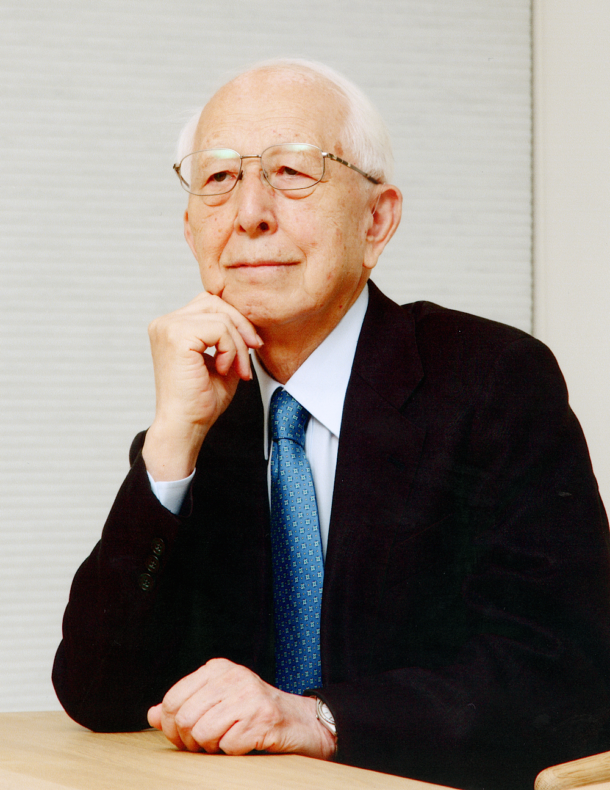

Fumihiko Maki. Photo courtesy of Maki and Associates.

Fumihiko Maki was born in Tokyo in 1928. After studies at The University of Tokyo, graduating (BS Arch) in 1952, he undertook further studies in the USA at the Cranbrook Academy of Art, Michigan and the Graduate School of Design (GSD), Harvard University, graduating with a Master of Architecture from each, in 1953 and 1954 respectively. Thereafter Maki worked for Skidmore, Owings & Merrill in New York, and for Sert, Jackson & Associates in Cambridge, Massachusetts. In 1956, he became assistant professor in architecture at Washington University, St Louis, its on-campus art centre Steinberg Hall his first design commission.

Maki was associate professor at Harvard’s GSD 1962–65, returning to Japan in 1965 to establish his own firm, Maki and Associates, also holding a professorship at the University of Tokyo, 1979–89.

Maki’s architectural oeuvre straddles Asia, North and South America, Europe, and the Middle East, encompassing a breadth of projects including art museums and performing arts venues; educational, research, and administrative institutions; conference, media, sports, and community centres; and residential projects among others. His practice has earned him innumerable awards including the Wolf Prize (1988), the Thomas Jefferson Medal in Architecture (1990), the UIA Gold Medal (1993), The Pritzker Architecture Prize (1993), Japan Arts Association Praemium Imperiale (1999), and the American Institute of Architects (AIA) Gold Medal (2011).

Early influences include Maki’s hometown, Tokyo, in the 1930s a large garden-laden city with a comparatively subdued character, punctuated by occasional examples of modernist architecture; the teachings of Kenzō Tange during student days at the University of Tokyo; and Chicago – which he accessed during his time in St Louis – with its pool of American modernism by architects Richardson, Sullivan, Wright, Burnham & Root, and post-Bauhaus internationalism of European émigrés Mies van der Rohe and László Moholy-Nagy. While on a period of extended travels through Asia, the Middle East, and Europe as a 1958 Graham Foundation fellow, Maki became associated with Metabolism, the Japanese architectural movement coming to prominence in tandem with the 1960 Tokyo World Design Conference. Referencing biological processes in the belief that the built environment should evolve in response to its surrounds as living organisms do, and injecting architectural practice with what its members saw as a necessarily updated outlook, their published manifesto *Metabolism: The Proposals for New Urbanism* included the essay *Towards the Group Form* penned by Maki and fellow architect Masato Ōtaka. While Maki was somewhat distanced from Metabolism during the 1960s, he was involved in the event’s acknowledged apotheosis, being Expo ’70 in Osaka. The proposition that buildings ‘liaise’ with their context appears to have accrued more resonance with Maki as he matured, arguably tempering some of the more orthodox principles of the modernist canon with which Maki is linked. Maki added to the core modernist palette he adopted – namely steel, concrete, and glass – with other materials such as porcelain tiles, anodised aluminium, and stainless steel, along with the incorporation of new technologies and specific modular construction methodologies.

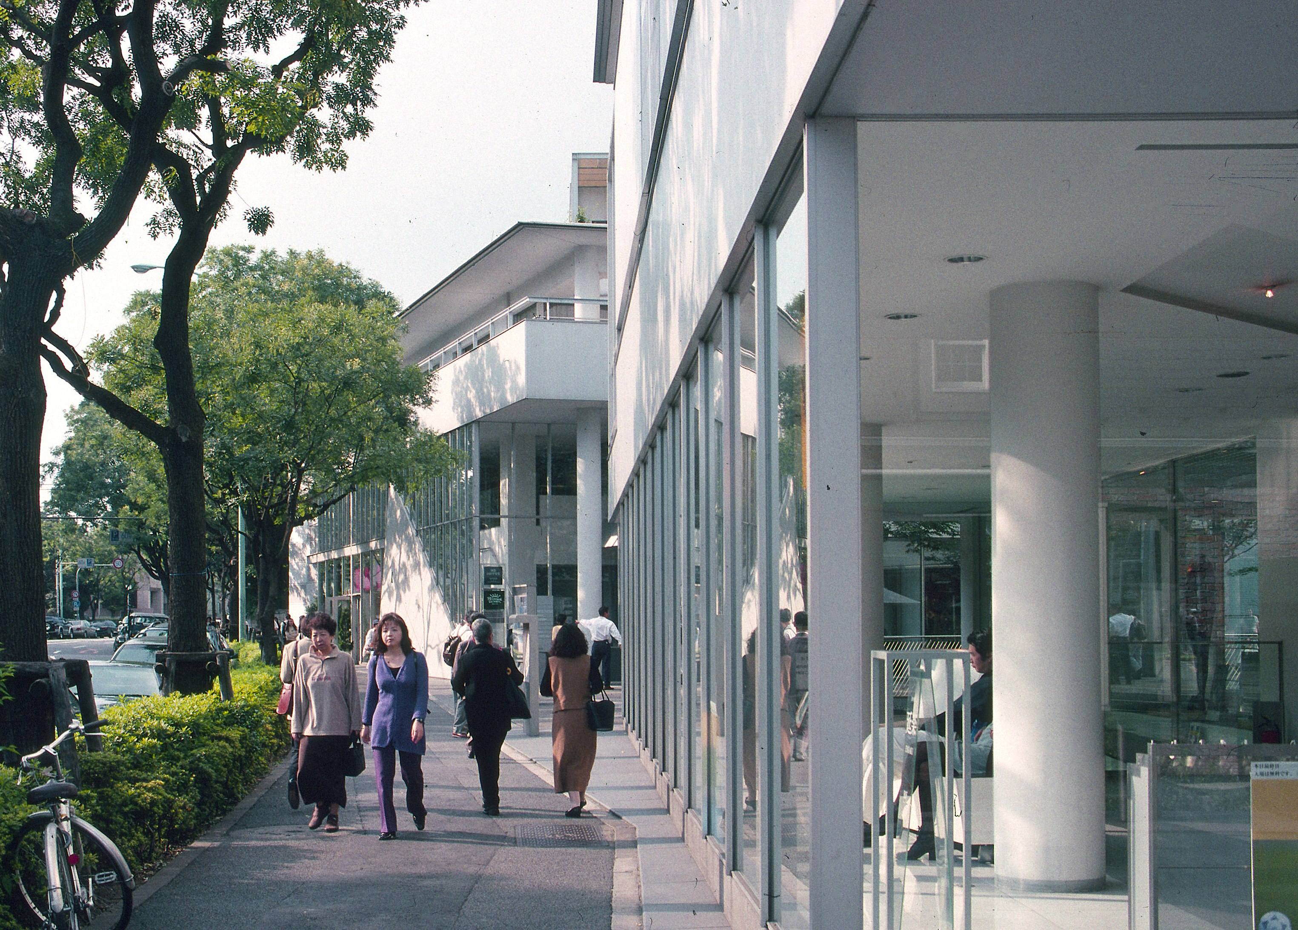

Fumihiko Maki, Hillside Terrace, Tokyo (1967-1992).

Photo courtesy of Maki and Associates.

Hillside Terrace, a six-part residential and commercial complex begun in Tokyo’s Daikanyama area in 1967 and completed in 1992, put into practice Maki’s ideas on ‘group form’. Alongside concepts of ‘compositional form’ and ‘megaform’, they were elaborated upon in his 1964 publication *Investigations in Collective Form*. The site comprises linked cube-like structures on an intimate scale and in a unified style, with articulated sidewalks, transitional spaces, and terracing further tempered by greenery and overall pedestrian friendliness. The length of time over which Hillside Terrace was completed, facilitating revisions to the primary plan, sees it as the project most closely related to Metabolism. Other early projects reflecting influences from Maki’s time in the USA include Nagoya University Toyoda Memorial Hall (1960), and Kanagawa Ward Office, Yokohama (1971).

The mid-70s saw Maki working on some quite expansive sites, such as Toyota Kuragaike Memorial Hall (1974) in Toyota, Aichi. Fujisawa Gymnasium (1984), in Kanagawa, may be regarded as a precursor of the lightness that became an integral component in Maki’s work. Its layered membranes of stainless steel, carried on long-span steel trusses, are further developed in large structures such as Makuhari Messe I & II (1989 & 1997) in Chiba (known also as Nippon Convention Center), and have a deftness and lightness of touch which differentiate his work from many modernist ‘megastructures’.

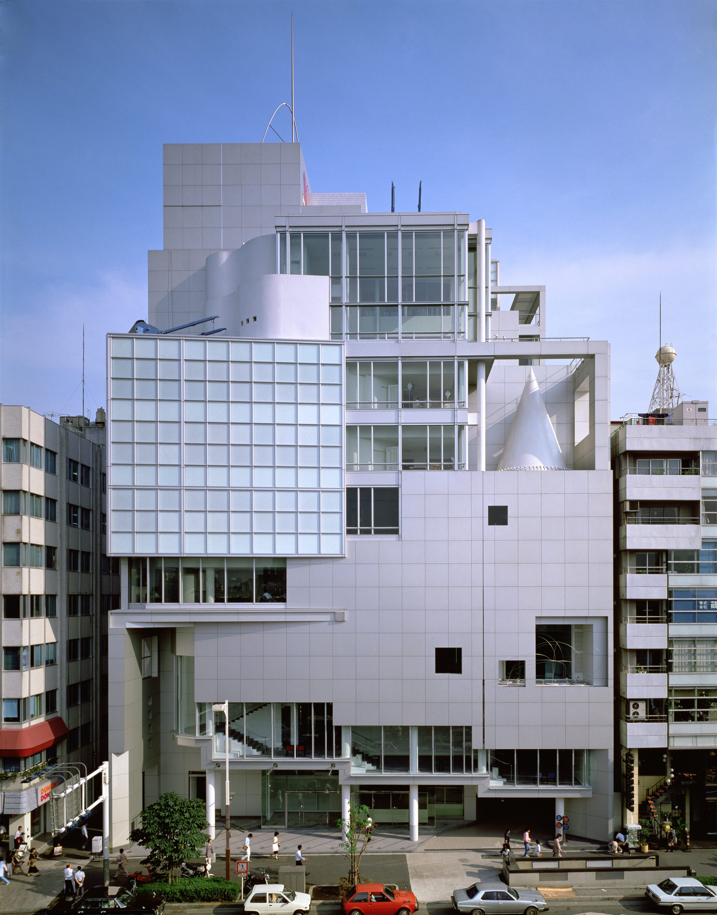

Fumihiko Maki, Spiral (front facade), Tokyo (1985).

Photo: Toshiharu Kitajima.

An ‘earthly’ ambience in Maki’s work has been an oft-noted observation: the responsiveness to place and to human need being a recurrent feature, one good example being Tokyo’s multipurpose arts venue Spiral (1985), its cantilevered geometry and tiered linkages somewhat reminiscent of Cubist painting composition; and its generous use of glass with two-way, internal-external viewing providing a sense of theatricality and heightened interaction. Speaking at the 1993 presentation of the Pritzker Architecture Prize to Maki, Columbia University architectural academic Kenneth Frampton remarked ‘… his syntax has changed across time, from the informal, cubic rationalism of the initial buildings, evidently indebted to Sert, to the tessellated minimalism of the middle period and the layered, light membraceous character of the last.’

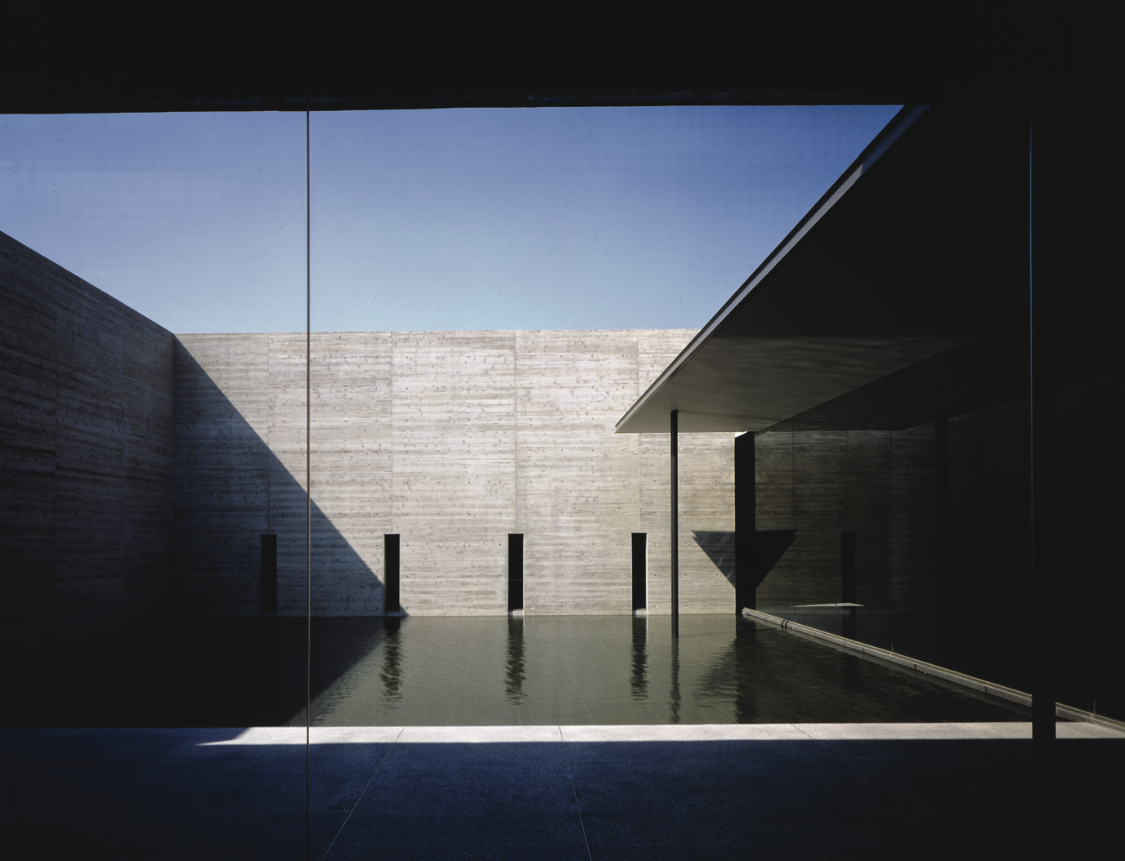

Fumihiko Maki, Kaze-no-Oka Crematorium Courtyard,

Oita, Japan (1997). Photo: Toshiharu Kitajima

The horizontality and airiness of San Francisco’s Yerba Buena Center for the Arts (1993), and the low-keyed sculptural understatement of the Kaze-no-Oka Crematorium (1997) in Oita, Japan, with its poignant transitional spaces, further exemplify the direction of Maki’s architectural language approaching the turn of the century.

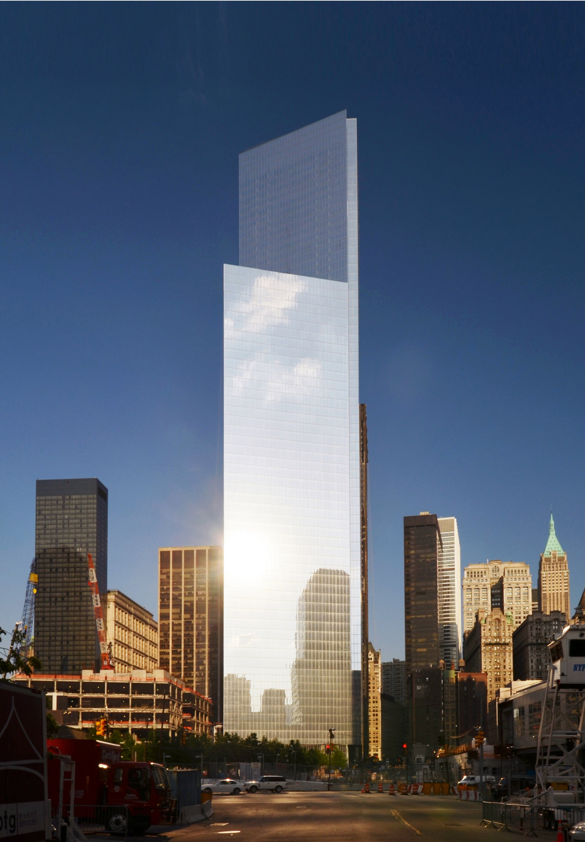

Fumihiko Maki, Tower 4, World Trade Center, NYC (2013).

Photo: Tectonic

The 21st century sees Maki having extended his global footprint with further projects in Asia, India, Europe, North America, and the Middle East, including but not limited to the following examples:

• United Nations Consolidation Building, New York, USA, 2017

• Singapore MediaCorp, Singapore, 2015

• Shenzhen Sea World Cultural Arts Center, Shenzhen, China,

2015

• The Bihar Museum, Patna, India, 2015

• Taipei Main Station Area Redevelopment, Taiwan, 2014

• Châteaucreux District Development, Saint-Étienne, France,

2013

• Tower 4, World Trade Center, New York, USA, 2013

• Aga Khan Museum, Toronto, Canada, 2013

• Machida City Hall, Tokyo, Japan, 2012

• International College for Postgraduate Buddhist Studies,

Tokyo, Japan, 2010

• MIT Media Lab Complex, Massachusetts, USA, 2009

• Novartis Square 3, Basel, Switzerland, 2009

• Jewish Community of Japan, Tokyo, Japan, 2009

• Republic Polytechnic, Singapore, 2007

• The Delegation of The Ismaili Imamat, Ontario, Canada, 2008

• Sam Fox School of Design & Visual Arts, Washington

University in St Louis, USA, 2006

• Maki-Solitaire, Dusseldorf, Germany, 2001

**Useful links**

Maki and Associates – Architecture and Planning

[www.maki-and-associates.co.jp](http://www.maki-and-associates.co.jp)

World Trade Center (section devoted to Maki’s Tower 4)

[www.wtc.com](http://www.wtc.com)

METABOLISM – THE CITY OF THE FUTURE: Dreams and Visions of Reconstruction in Postwar and Present-Day Japan. Exhibition at Mori Art Museum, Tokyo, 2011-2012. <http://www.mori.art.museum/english/contents/metabolism/index.html>

Hillside Terrace Project

<http://www.hillsideterrace.com>

**Further reading**

GARDNER, James (April, 2014) *Maki’s 4 WTC Offers Shimmering Perfection*. Architecture Review of 4 WTC, NYC. New York: The Real Deal (magazine & website)

<http://therealdeal.com/issues_articles/maki-strikes-again-at-4-wtc/>

MAKI, Fumihiko; FRAMPTON, Kenneth; MULLIGAN, Mark; STEWART, David (2012) *Fumihiko Maki* (monograph). London: PHAIDON (ISBN: 9780714849560)

MAKI, Fumihiko; MULLIGAN Mark (2008/2012) *Nurturing Dreams – Collected Essays on Architecture and the City* Cambridge, MA: MIT Press (ISBN: 9780262135009 / 9780262518185)

A+U (July 2012) *Power of Space: Fumihiko Maki’s Recent Works 2007-2015* (Special Issue) Japan Architecture + Urbanism (English/Japanese;160 pages).

ISBN: 9784900211711

<https://www.japlusu.com/shop/product/au-july-2012-special-issue>

MAKI, Fumihiko (1964) *Investigations in Collective Form* St Louis, USA: The School of Architecture, Washington University <http://library.wustl.edu/units/spec/archives/photos/maki/maki-part1.pdf>